1. Introduction
This document explains the different deployment approaches for SAP Work Zone in both the Standard Edition and Advanced Edition. It covers:
- Deployment of SAP Fiori applications
- Deployment of UI Cards
- Deployment of Content Packages
- Key differences between manual, ZIP, and MTA-based deployments

2. Deployment of Fiori Applications
SAP Work Zone supports two main deployment approaches. Both start with creating an application using Visual Studio Code and the SAP Fiori Application Generator.
2.1 Local Setup and Testing
- Generate the app via:
VS Code → Command Palette → “Fiori: Application Generator”
- Test locally:
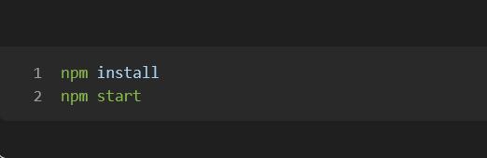

3. Deployment Method 1 (Legacy) — Cloud Foundry + HTML5 Repo + MTA
This approach converts the project into an MTA manually.
3.1 Build Steps
Step | Command | Description
Build UI | npm run build | Creates /dist folder
CF prep | npm run build:cf | Prepares CF structure
MTA build | mbt build | Generates .mtar package
Deploy | cf deploy mta_archives/app.mtar | Uploads app + creates services

3.2 Characteristics
- More complex
- Easy to misconfigure
- App may not appear automatically in the Launchpad

4. Deployment Method 2 — Full MTA + FLP Integration
This is the recommended and most consistent method.
4.1 Steps
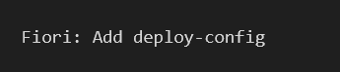
- Add Deployment Config:

Adds CF services, HTML5 repo config, updates mta.yaml.

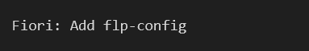
- Add FLP configuration:

Generates semantic object, action, title. -> this is done in the command palette.
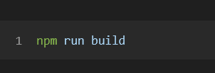
- Build app:

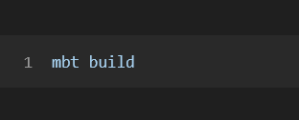
- Build MTA:

- Deploy
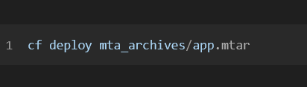

4.2 Advantages
Legacy CF Deploy | Full MTA Deploy
Static hosting | Enterprise workflow
No FLP tile | Creates Work Zone tile
No semantic objects | Uses semantic objects
Manual integration | Automatic integration

5. Deploying UI Cards
UI Cards follow a different process.
See: “Creating a Content Package with 6 UI Cards” for the detailed guide.
SAP Work Zone supports:
- ZIP-based upload (Standard Edition)
- MTA-based deployment (Advanced Edition)

6. Deploying Content Packages
There are two deployment approaches:

6.1 Method A — ZIP Upload (Standard Edition)
- Prepare the content package folder structure
- Package the content package (zip it)
- Upload in Work Zone → Content Manager → Upload Content
This method is simple and recommended for Standard Work Zone.

Deployment Methods for Content Packages to SAP Work Zone

1. Introduction
In SAP Work Zone Standard Edition, a content package is a container for multiple UI cards, applications, or other content that can be displayed in channels. Deploying content packages allows business users to add new apps, cards, and workflows to their Work Zone environment.

2. Methods for Deploying Content Packages
Method 1 — ZIP Upload via Content Manager (Most Common)
Description:
This is the most widely used method in Standard Edition. You prepare the content package locally, compress it into a ZIP file, and upload it through the Work Zone Content Manager.
Steps:
- Prepare the content package
  - Ensure all your UI cards, app references, and configuration files are inside a single folder.
- Zip the content package folder
  - Compress it to a single .zip file (do not include parent folder).
- Upload the ZIP in Work Zone
  - Go to Work Zone → Content Manager → Upload Content
  - Select your ZIP file and follow the prompts.
- Publish / Assign to a channel
  - After uploading, you can assign the content package to a channel or specific users.
Advantages:
- Simple and fast for Standard Edition.
- Does not require a Cloud Foundry or MTA deployment.
- Ideal for UI cards and small sets of apps.
Limitations:
- No automatic integration with Launchpad tiles or semantic objects.
- Manual process; not suited for CI/CD pipelines.

Method 2 — MTA Deployment (Advanced / Optional)
Description:
Advanced Edition (or Enterprise deployments) allows you to wrap content packages as MTA modules, which are deployed to Cloud Foundry using .mtar packages. This enables CI/CD integration, automatic tiles in Work Zone, and semantic object navigation.
Steps:
- Wrap your content package in an MTA module.
- Include the Work Zone Content Deployer module.
- Build the MTA using:
mbt build
- Deploy the .mtar to CF:
cf deploy mta_archives/<your-package>.mtar
Advantages:
- Automated tile creation and navigation integration.
- Scalable for multiple packages or larger enterprise deployments.
- Supports CI/CD pipelines.
Limitations:
- Not available in Standard Edition (only in Advanced Edition).
- More complex; requires Cloud Foundry access and MTA tooling.

Deploying a app via CI/CD to work zone standard
https://developers.sap.com/tutorials/set-up-cicd.html

First of all we need to subscribe to the Continuous Integration and Delivery
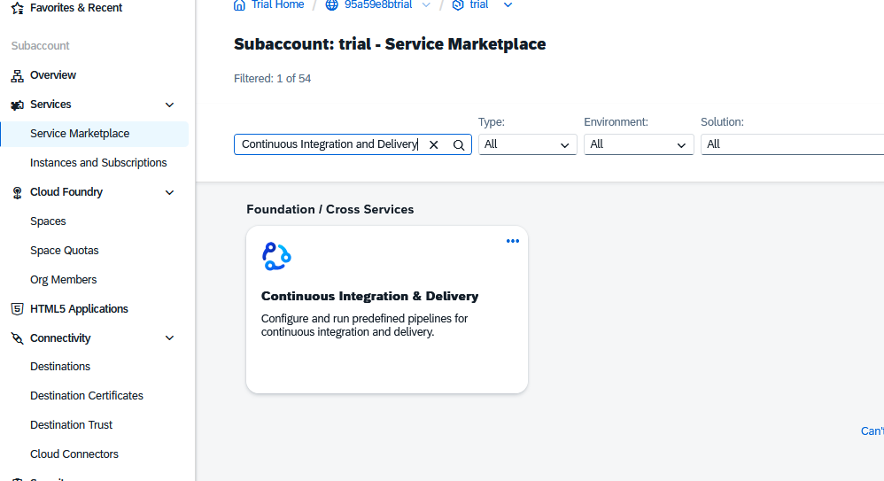

Then it comes under the subscriptions -> Make sure you added the admin role to the user
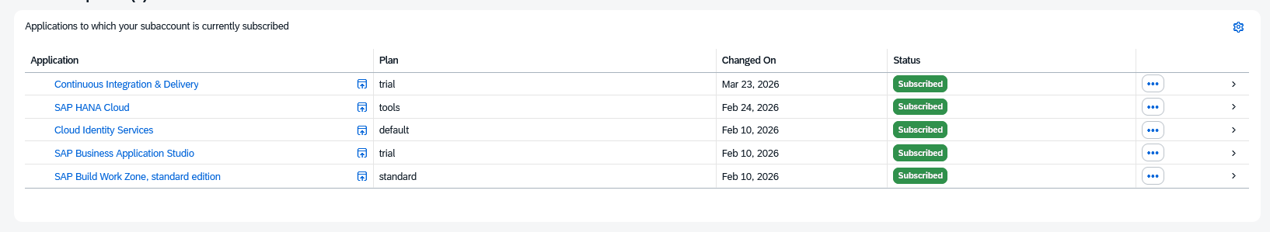

Open the app
Now we are going to connect the CI/CD to the credentials;
We have two
  - The one of the Github where the code is pushed to
  - The BTP where the code needs to be deployed to
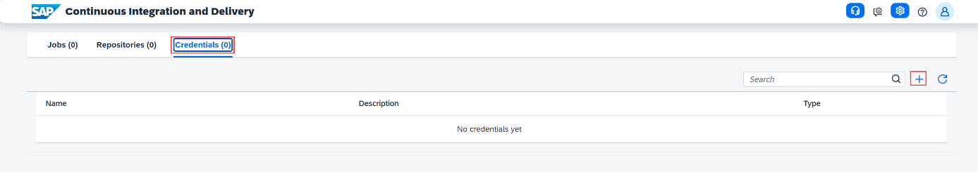

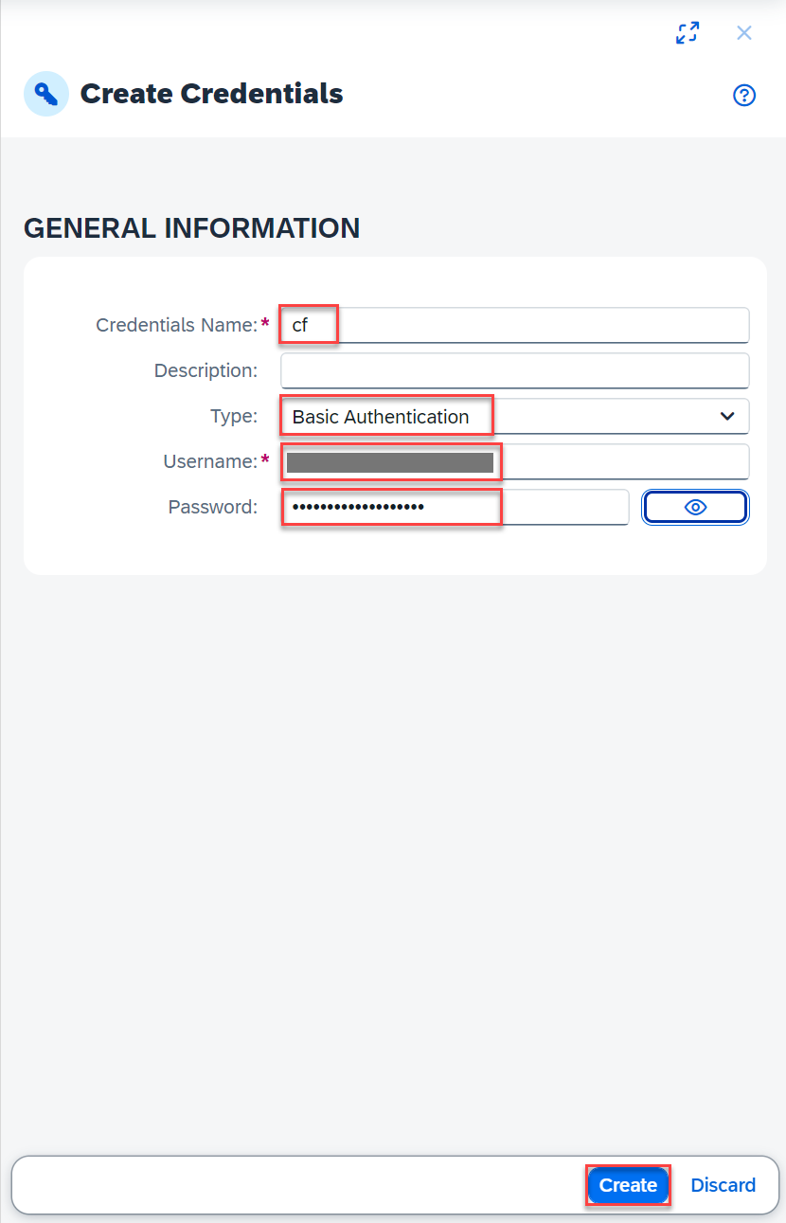
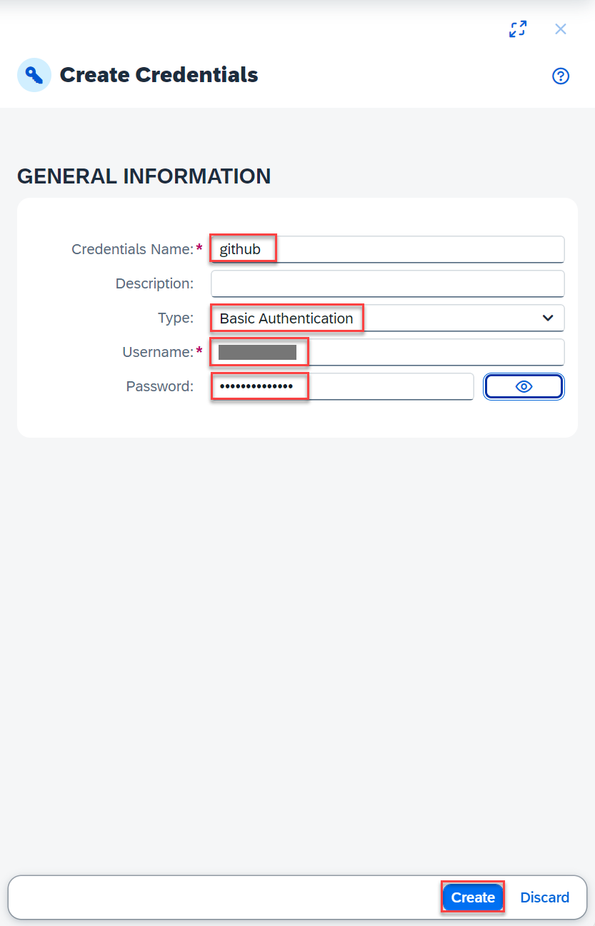

In the git you will need to create a Personal Access token, to be able to enter the git.

Settings developer settings -> personal access token -> Tokens
Give it a useful name, and select the full repo scope

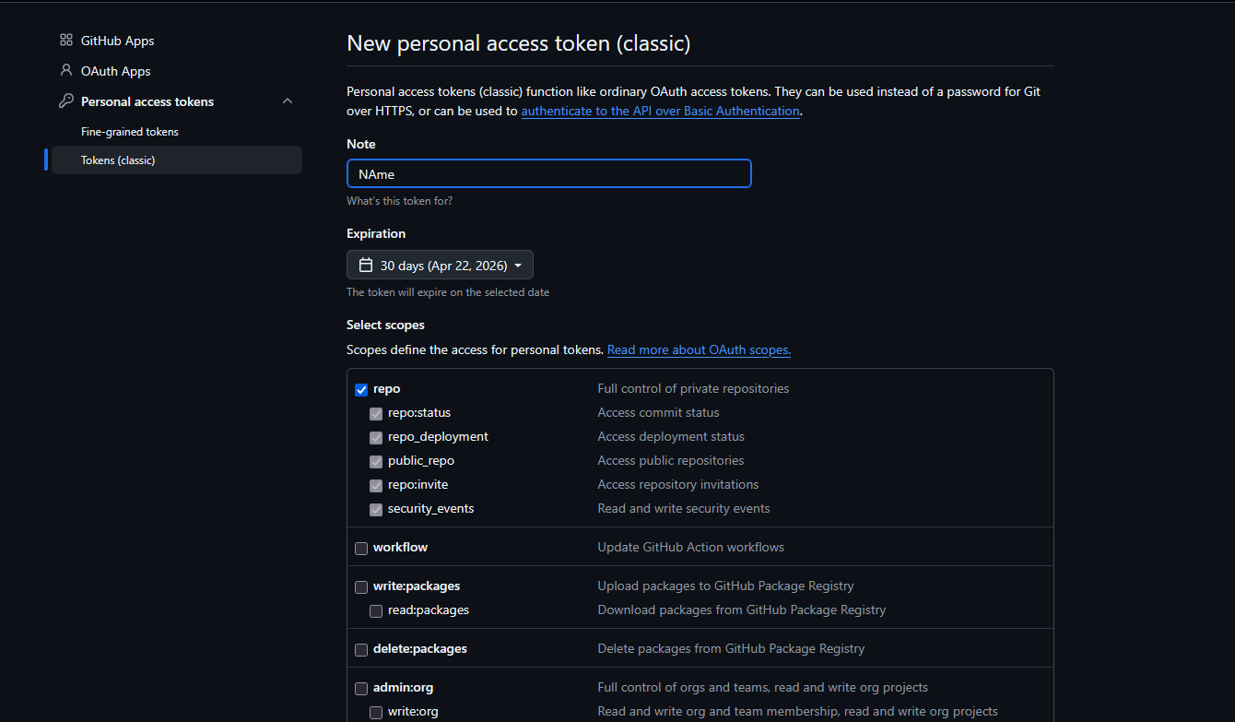
Make sure to copy the secret key.
Because that is the one we will use as the
Password for the github credentials
In combination with the username of the git
As Username.

For the cf credentials we will use the basic log-in credentials of the btp user

Now we have the credentials ready
we will create our job that get’s the code from the github repo to the btp
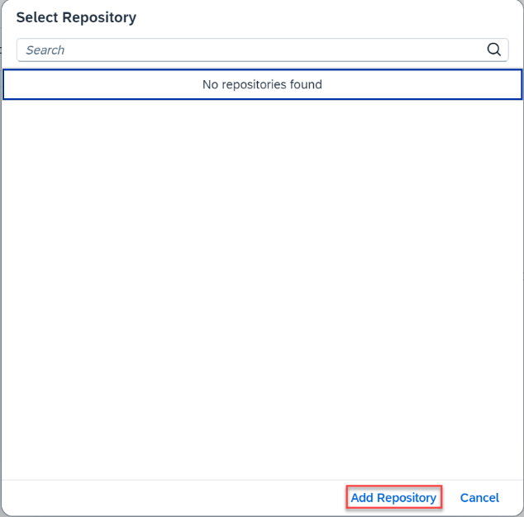
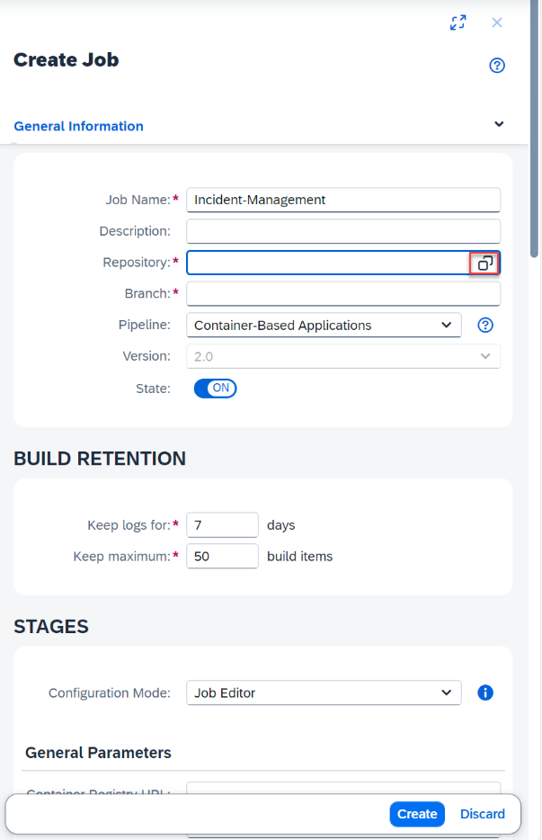

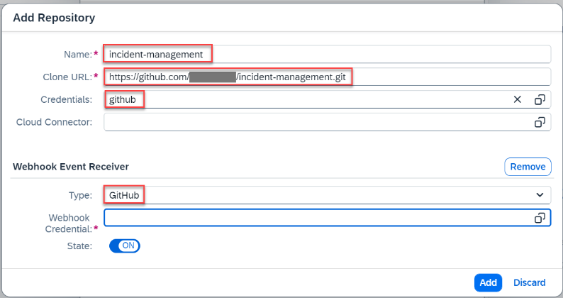

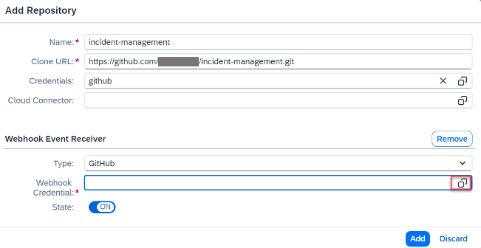
We will clone the url of the git repo and place it in the add repo + connect it to the github credentials.
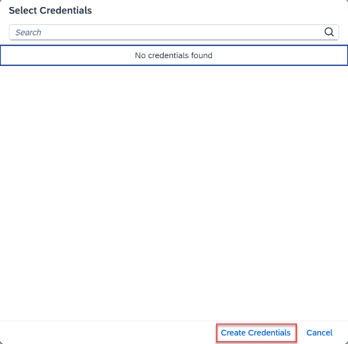
Then we need to connect a webhook:

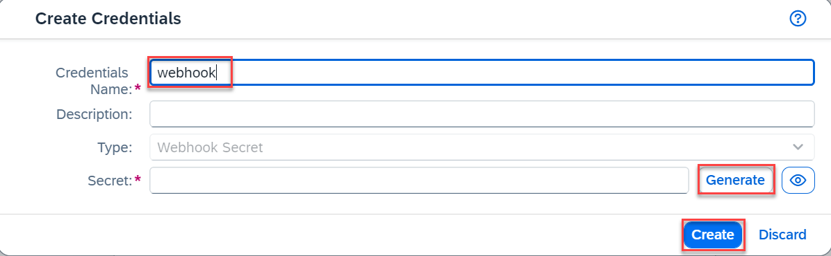

Generate a secret and copy this, this we will need for the git webhook!!
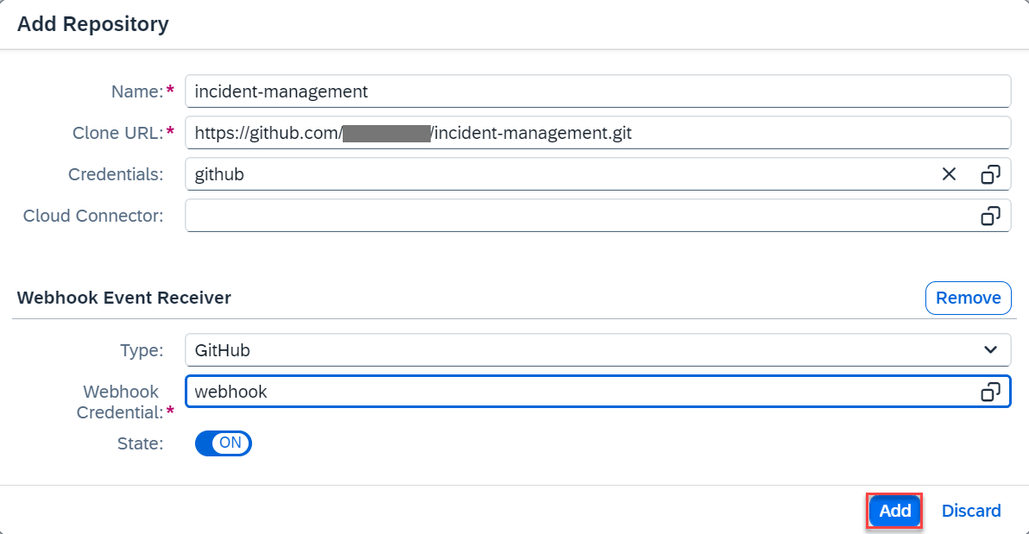

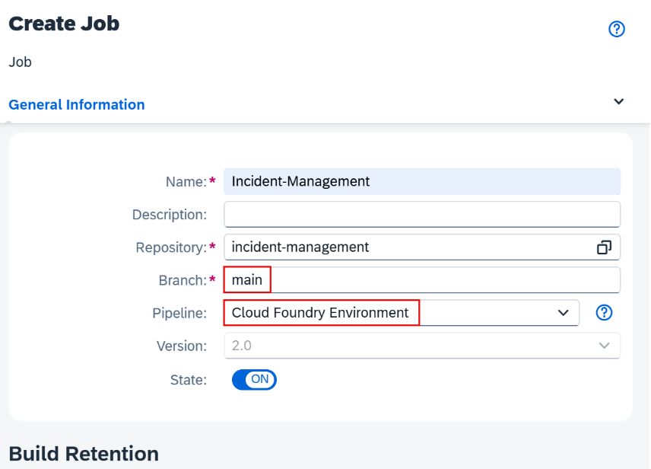
And after that simple click add

Then we will configure the pipeline and stages:

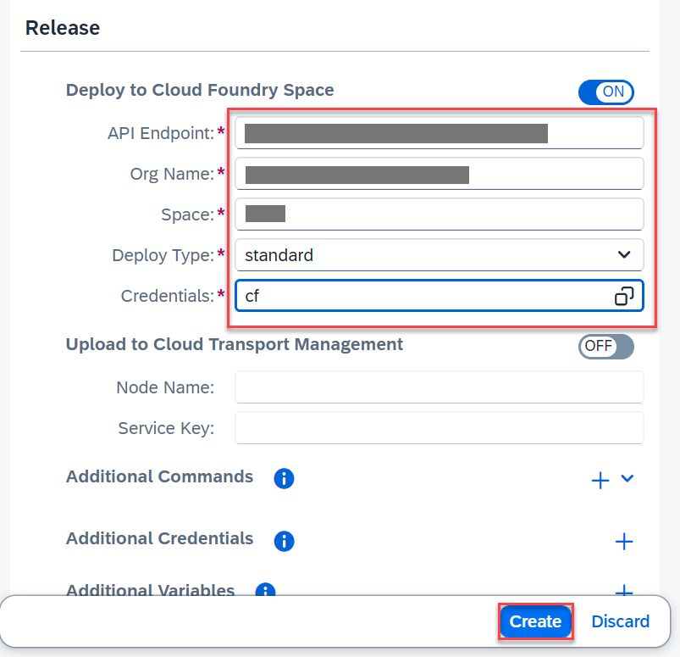
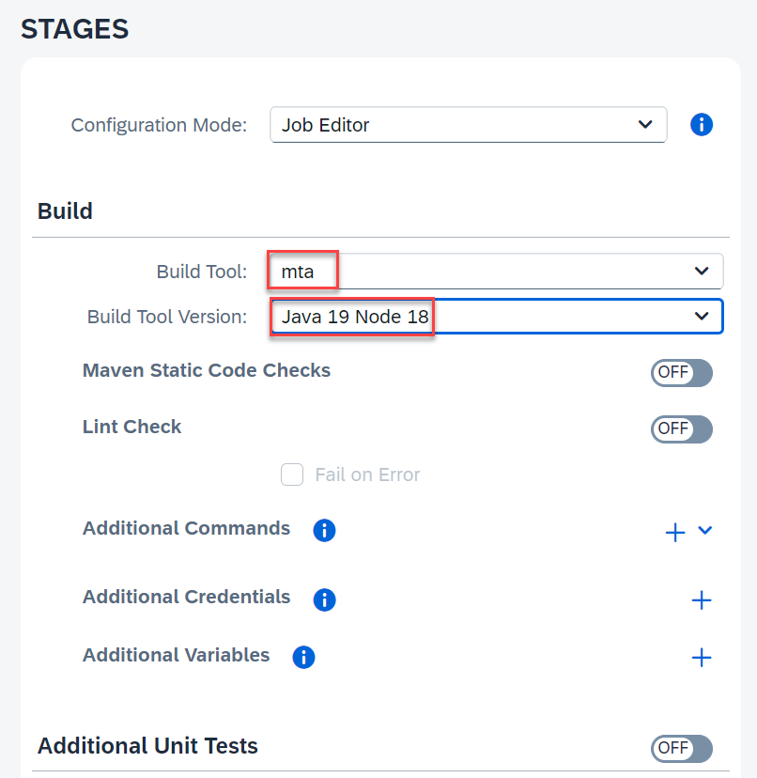

In the release fill in the credentials of you find at the overview of the subaccount.

To make it automatic, that when you push the changes to git it automatically runs the job. We need to create a webhook.
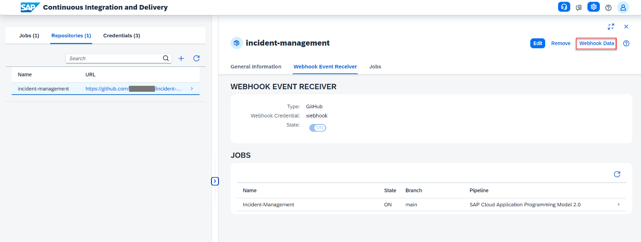

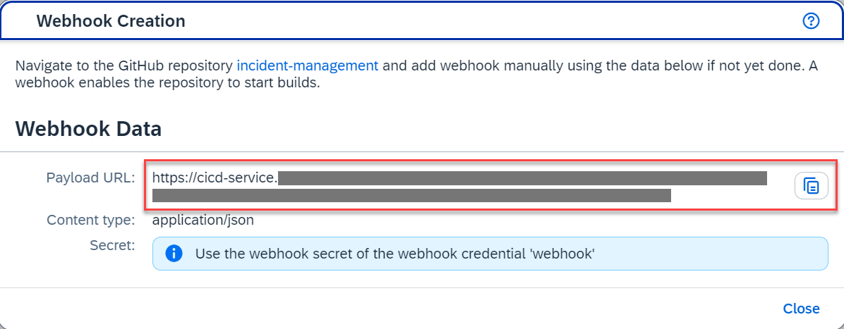

Then we go to git and create a webhook inside the correct repo.
So go to the git repo -> settings -> webhook
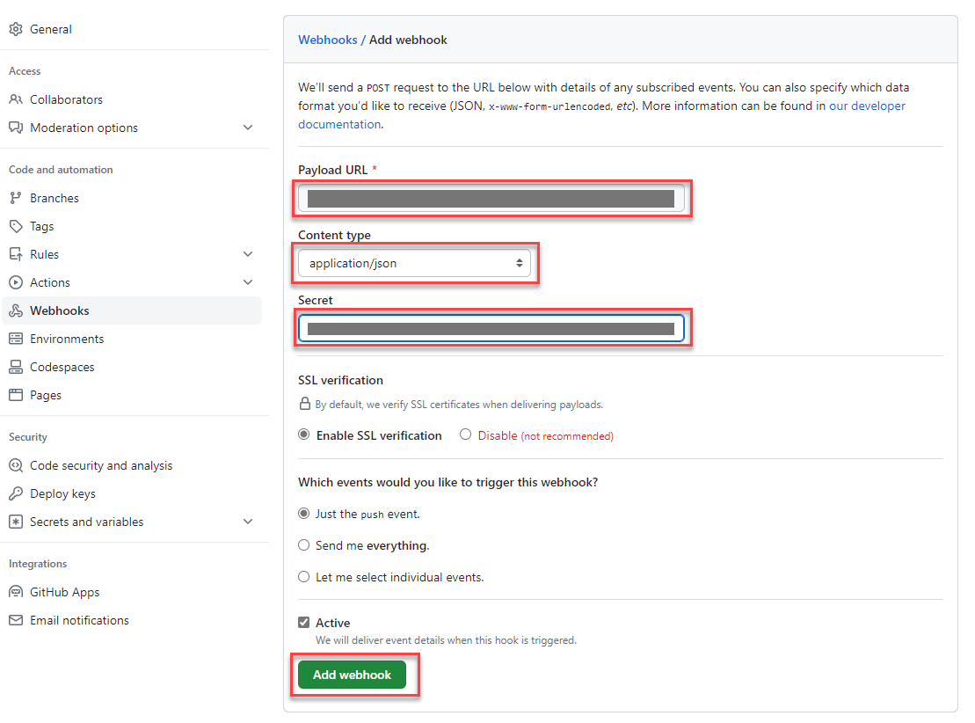

The url is the one you just copied, the secret is the one you created when creating the webhook on the job.

If there are problems with the deployment to btp
  - Look in the: /APP/WEBAPP/manifest.json
  - In datasource find; OdataVersion
  - Change it to 4.0!!!!!!!!!!!!

